Project Design Phase-II

Data Flow Diagram & User Stories

|  |  |
| --- | --- |
| Date | 01-11-2022 |
| Team ID | PNT2022TMID01111 |
| Project Name | Personal Assistance for Seniors Who Are Self-Reliant |
| Maximum Marks | 4 Marks |

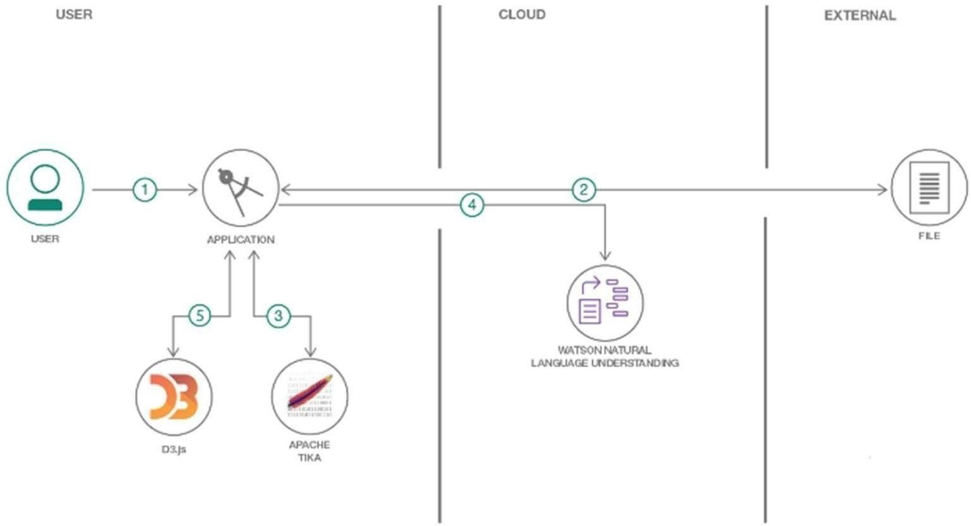

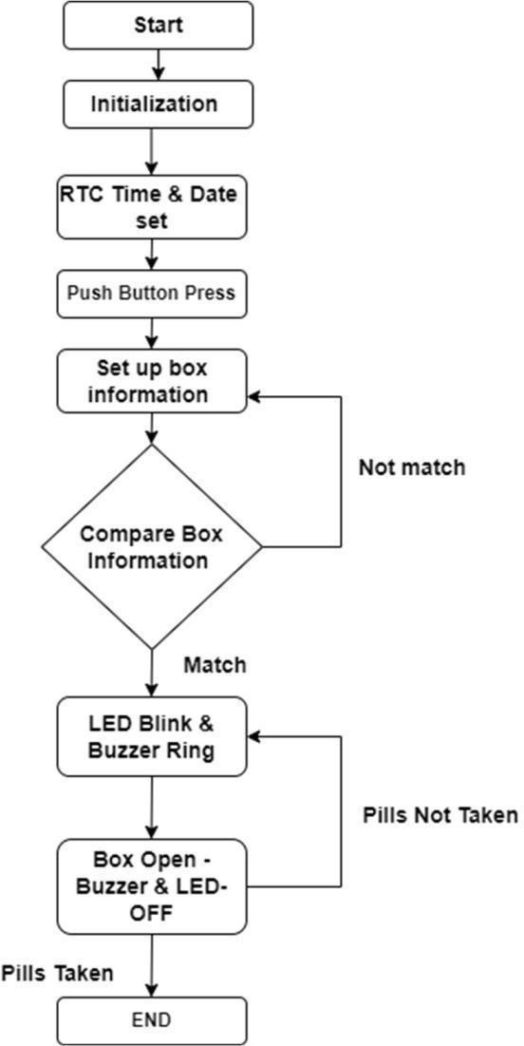

User Stories

|  |  |  |  |  |  |  |
| --- | --- | --- | --- | --- | --- | --- |
| User Type | Functional Requireme nt(Epic) | User Story Number | User Story / Task | Acceptance criteria | Priority | Release |
| Customer  (Senior citizen) | Caretaker | USN-1 | As a user, I want to take Medicines on time and monitor my health | I want to Take Medicines On time | High | Sprint-1 |
| Customer (Alzheimer patient) | Smart medicine box | USN-2 | As a user, I want to take my tablets on time by voice command | I want to take my tablets on time by voice command | High | Sprint-1 |
| Customer (Mentally idled patient) | Caretaker | USN-3 | As a user, my patient needs to take medicines on time and monitoring the activity | My patient needs to take medicines on time | Medium | Sprint-2 |
| Customer (Coma patient) | Caretaker | USN-4 | As a user, my patient medication time and prescription should load in database for upcoming week | My patient medication time and prescription should be in database list | Low | Sprint-4 |
| Customer (Disable d  people’s) | Smart medicine box | USN-5 | As a user, I need to take my medicine in nearby places with light notification | I need to take my medicine in nearby places with Light notification | Medium | Sprint-3 |
| Customer(No Clear Vision ) | Smart medicine box | USN-6 | As a user, I need to take my medicine and I am not able see the dosage of medicine properly | Scan the medicine | High | Sprint-1 |
| Customer(No Clear Vision ) | Smart medicine box | USN-7 | As a user, Sometimes my medicine aren’t in stock and I usually forget the Stock of my medication. | Stock remainder | Medium | Sprint -1 |